Spearman rank correlation: NZDUSD and USDCHF
Method 02 / daily log returns / Alpari D1 full available history

Study setup
Logical pair: NZDUSD , USDCHF
Broker symbols: NZDUSD_i , USDCHF_i
Snapshot: 2026-11-03_majors_alpari_D1
Timeframe: D1
Matched return window: 1999-01-05 to 2026-11-02 (UTC bar dates)
Matched return count n: 7185
Dropped unfinished last bar dated 2026-11-03 UTC after a tick-volume check against the prior complete day.
Complete matched rows (CSV): NZDUSD-USDCHF_Spearman_D1.csv
Complete matched rows (HTML table): NZDUSD-USDCHF_Spearman_D1_data.html

Method carried forward
Spearman rho is Pearson correlation on the ranks of matched daily log returns of close, ln(close_t / close_t-1), in the broker quote direction. Ties use average ranks. Quotes are not inverted. rho is symmetric under swap of the two symbols. rho = 0 means no consistent rank-order link in this sample; it does not mean no link of any kind. The score is not a cause, not a lead, and not a trading signal. Daily rows are not independent draws, so the two-sided p-value and approximate Fisher interval are reported and treated as secondary to rho. Same-sample Pearson r is shown only as a side check; a large rho minus r gap can flag outliers or a non-straight link.

Results
Spearman rho: -0.433752
Two-sided p-value: 0
Approximate 95% Fisher interval: [-0.452339, -0.414789]
Same-sample Pearson r: -0.393600
rho minus r: -0.040153

Conclusion
Over 7185 matched daily log-return rows for NZDUSD and USDCHF (broker quote directions unchanged), Spearman rho is -0.4338 (negative, moderate rank-order association in this sample). Approximate 95% Fisher interval: [-0.4523, -0.4148]. Same-sample Pearson r is -0.3936 (rho minus r = -0.0402). Two-sided p under the usual independent-ranks model is 0; that model does not match linked daily FX returns, so treat p as secondary. This does not establish cause, lead-lag, or a lasting trading rule.

Charts
Daily closes

Daily log returns
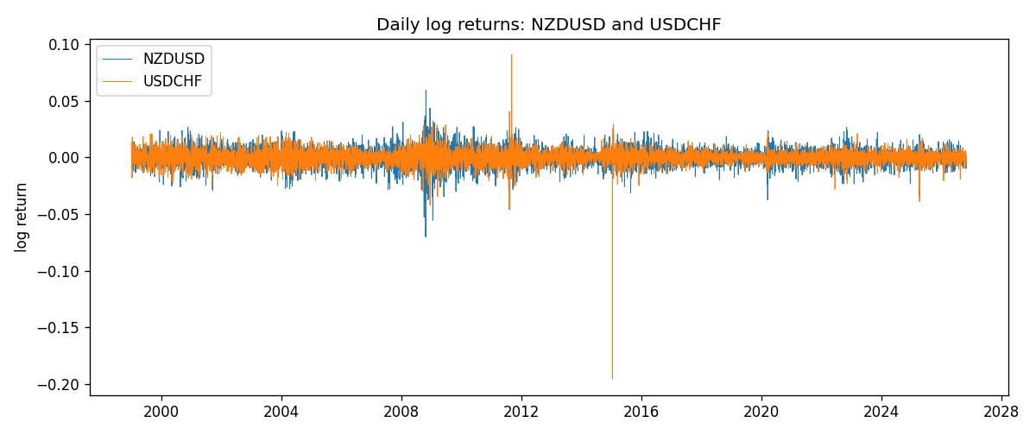
Log-return scatter
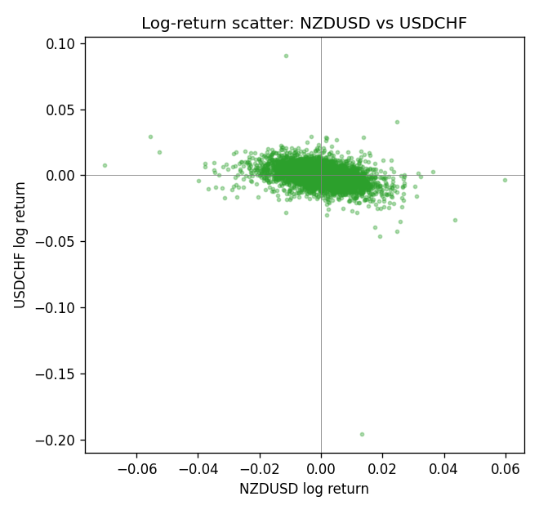
Rank-rank scatter
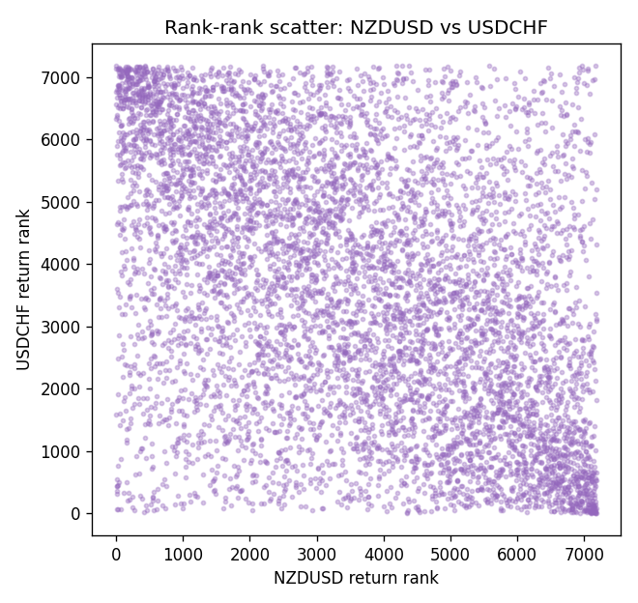

Data report
Every matched row that entered Spearman rho is stored in the sibling CSV named NZDUSD-USDCHF_Spearman_D1.csv. That file is the complete data archive for redrawing charts. Embedding all rows as a Word table is impractical at this length; the Word file holds the column list, column summaries, and the first and last 15 matched rows.
Columns: time, NZDUSD_open, USDCHF_open, NZDUSD_high, USDCHF_high, NZDUSD_low, USDCHF_low, NZDUSD_close, USDCHF_close, NZDUSD_tick_volume, USDCHF_tick_volume, NZDUSD_spread, USDCHF_spread, NZDUSD_real_volume, USDCHF_real_volume, NZDUSD_log_return, USDCHF_log_return
Column summaries (matched calculation rows)
column | count | mean | std | min | 25% | 50% | 75% | max
NZDUSD_open | 7185 | 0.65641395 | 0.10821881 | 0.3913 | 0.59137 | 0.6684 | 0.72499 | 0.88218
USDCHF_open | 7185 | 1.0976269 | 0.25248305 | 0.72022 | 0.92053 | 0.98988 | 1.2378 | 1.8219
NZDUSD_high | 7185 | 0.66033247 | 0.10871106 | 0.3961 | 0.59478 | 0.672 | 0.72937 | 0.88421
USDCHF_high | 7185 | 1.1029176 | 0.25422469 | 0.73305 | 0.92474 | 0.99353 | 1.2423 | 1.8313
NZDUSD_low | 7185 | 0.65272894 | 0.10781325 | 0.3897 | 0.58811 | 0.66417 | 0.72099 | 0.87988
USDCHF_low | 7185 | 1.0925083 | 0.25089773 | 0.08565 | 0.91719 | 0.98622 | 1.2317 | 1.8121
NZDUSD_close | 7185 | 0.65649284 | 0.10821292 | 0.3907 | 0.59165 | 0.6684 | 0.72502 | 0.8822
USDCHF_close | 7185 | 1.0976163 | 0.25237603 | 0.72025 | 0.92079 | 0.98995 | 1.2379 | 1.8217
NZDUSD_tick_volume | 7185 | 68718.644 | 123140.12 | 16 | 5587 | 33899 | 58511 | 1127682
USDCHF_tick_volume | 7185 | 74335.19 | 113494.16 | 18 | 12810 | 40241 | 70443 | 858589
NZDUSD_spread | 7185 | 30.278775 | 25.647496 | 0 | 9 | 17 | 40 | 80
USDCHF_spread | 7185 | 26.036326 | 24.697816 | 0 | 5 | 16 | 50 | 100
NZDUSD_real_volume | 7185 | 1.6703703e+10 | 8.4983725e+10 | 0 | 0 | 0 | 0 | 2.705649e+12
USDCHF_real_volume | 7185 | 2.3294091e+10 | 8.9133595e+10 | 0 | 0 | 0 | 0 | 1.9331921e+12
NZDUSD_log_return | 7185 | 2.019e-05 | 0.00763908 | -0.07027433 | -0.0042485 | 0.00023717 | 0.00458461 | 0.05966839
USDCHF_log_return | 7185 | -7.205e-05 | 0.00658891 | -0.19545699 | -0.0033516 | 8.095e-05 | 0.00331593 | 0.09051364
First 15 matched rows (selected columns)
time | NZDUSD_close | USDCHF_close | NZDUSD_log_return | USDCHF_log_return | NZDUSD_tick_volume | USDCHF_tick_volume
1999-01-05 | 0.5372 | 1.3724 | -0.0018597736 | 0.0039424743 | 748 | 4666
1999-01-06 | 0.5383 | 1.3912 | 0.0020455609 | 0.013605652 | 823 | 3740
1999-01-07 | 0.5417 | 1.3782 | 0.0062963171 | -0.0093883841 | 878 | 4262
1999-01-08 | 0.5414 | 1.3935 | -0.00055396548 | 0.011040268 | 668 | 5991
1999-01-11 | 0.547 | 1.4009 | 0.010290425 | 0.0052963193 | 681 | 5236
1999-01-12 | 0.5441 | 1.3872 | -0.0053157489 | -0.0098275602 | 793 | 5975
1999-01-13 | 0.5387 | 1.3621 | -0.0099742238 | -0.018259701 | 1050 | 7036
1999-01-14 | 0.5386 | 1.3588 | -0.00018564931 | -0.0024256692 | 1137 | 5825
1999-01-15 | 0.5382 | 1.3834 | -0.00074294208 | 0.01794228 | 1124 | 7434
1999-01-18 | 0.5372 | 1.379 | -0.0018597736 | -0.0031856384 | 1022 | 4965
1999-01-19 | 0.5382 | 1.3789 | 0.0018597736 | -7.2518946e-05 | 1389 | 5494
1999-01-20 | 0.5404 | 1.3889 | 0.0040793678 | 0.0072259871 | 1678 | 5477
1999-01-21 | 0.5426 | 1.3836 | 0.0040627941 | -0.0038232689 | 1599 | 4736
1999-01-22 | 0.5361 | 1.3834 | -0.012051689 | -0.0001445609 | 1328 | 4833
1999-01-25 | 0.5342 | 1.3868 | -0.0035504102 | 0.0024546976 | 1035 | 3996
Last 15 matched rows (selected columns)
time | NZDUSD_close | USDCHF_close | NZDUSD_log_return | USDCHF_log_return | NZDUSD_tick_volume | USDCHF_tick_volume
2026-10-13 | 0.56127 | 0.83244 | 0.0047326165 | -0.0024955621 | 27958 | 32763
2026-10-14 | 0.55918 | 0.83489 | -0.0037306483 | 0.0029388325 | 37319 | 40903
2026-10-15 | 0.56185 | 0.82676 | 0.0047634855 | -0.0097855323 | 43714 | 54132
2026-10-16 | 0.56509 | 0.82377 | 0.0057501001 | -0.0036230826 | 35806 | 47176
2026-10-19 | 0.56616 | 0.82677 | 0.0018917133 | 0.0036351779 | 32069 | 40610
2026-10-20 | 0.56827 | 0.8246 | 0.0037199341 | -0.0026281224 | 34470 | 42106
2026-10-21 | 0.57003 | 0.82427 | 0.0030923331 | -0.00040027413 | 30020 | 37648
2026-10-22 | 0.56815 | 0.82032 | -0.0033035227 | -0.0048036381 | 39159 | 50809
2026-10-23 | 0.56991 | 0.82497 | 0.0030929853 | 0.005652514 | 33693 | 45872
2026-10-26 | 0.56826 | 0.82649 | -0.0028993932 | 0.0018407959 | 30716 | 41336
2026-10-27 | 0.56811 | 0.82865 | -0.00026399852 | 0.0026100526 | 32660 | 35560
2026-10-28 | 0.56261 | 0.82781 | -0.0097283914 | -0.0010142111 | 42740 | 42431
2026-10-29 | 0.56296 | 0.82379 | 0.00062190714 | -0.0048680164 | 40247 | 53780
2026-10-30 | 0.56307 | 0.82438 | 0.00019537668 | 0.00071594559 | 39305 | 55459
2026-11-02 | 0.56161 | 0.81851 | -0.0025962955 | -0.0071459744 | 35347 | 45329

